Documentation – graphs

Repsresentation:

Double dictionaries (int, list<int>) and a cost dict(pair<int, int>, int)

def __init__(*self*, *nrV*):

self._dictIn = {}

self._dictOut = {}

self._costDict = {}

Graph 1:

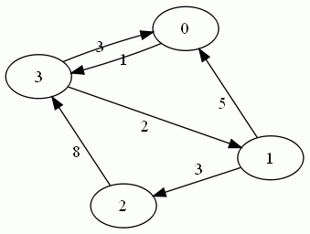

Self._dictIn: { 0: [1, 3],

1: [3],

2: [1],

3: [0, 2]

}

Self._dictOut: { 0: [3],

1: [0, 2],

2: [3],

3: [0, 1]

}

Self._costDict: {

(0, 3): 1,

(1, 0): 5,

(1, 2): 3,

(2, 3): 8,

(3, 0): 3

}

Graph 2:

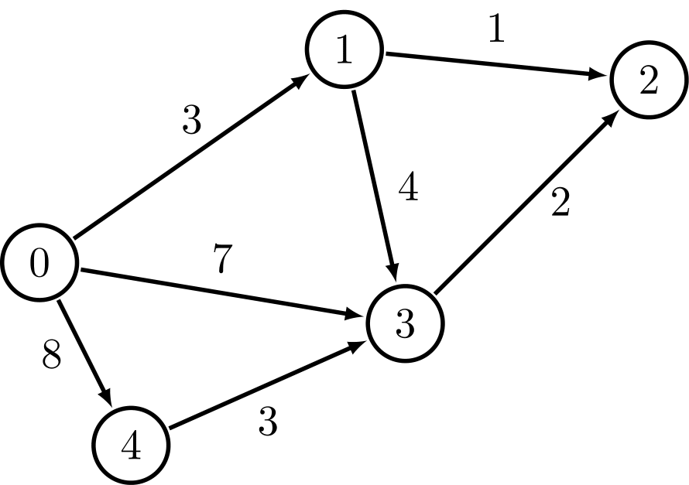

Self._dictIn: { 0: [], 1: [0], 2: [1, 3], 3:[0, 1, 4], 4: [0]}

Self._dictOut: { 0: [1, 3, 4], 1: [2, 3], 2: [], 3: [2], 4: [3]}

Self._costDict: { (0, 1): 3, (0, 3): 7, (0, 4): 8, (1, 2): 1, (1, 3): 4, (3, 2): 2, (4, 3): 3 }